-22AIE303-

**Name: Girish S Roll No: AM.EN.U4AIE22044**

DATABASE MANAGEMENT SYSTEMs

# Labsheet 3

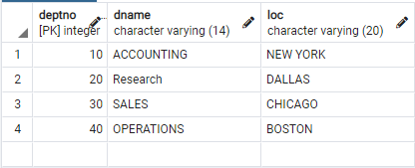

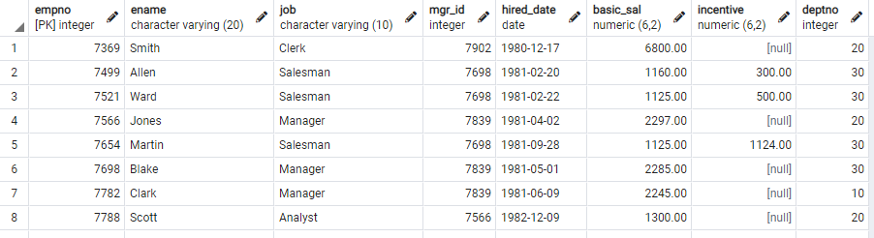



create table Department_locn (deptno integer references department(deptno), location varchar(20), primary key(deptno, location));

select * from Department_locn;





update employee set empno= 5 where ename = 'Meena';

select * from employee;

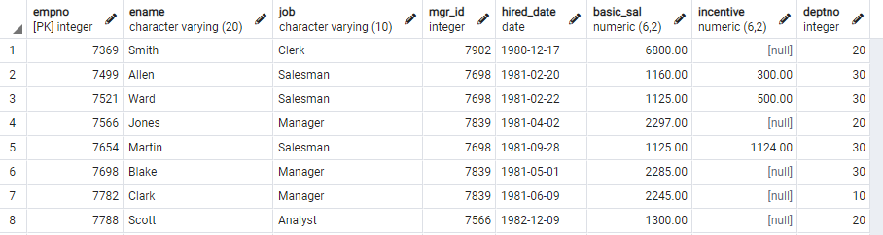



alter table employee drop column hired_date;

select * from employee;

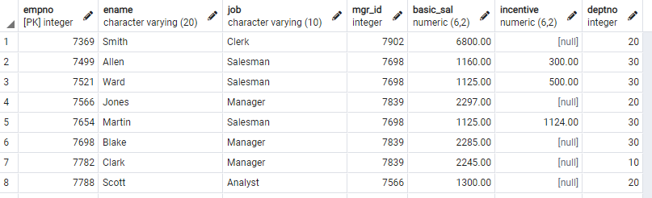



select * from Department where deptno in (1, 4, 8);

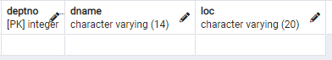



select distinct basic_sal from employee;

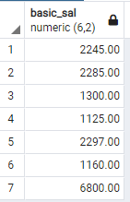



select * from Department order by deptno;

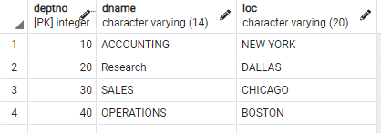



create table emp as select empno, ename, basic_sal from employee with no data;

select * from emp;





Insert into emp select empno, ename, basic_sal from employee;

select * from emp;

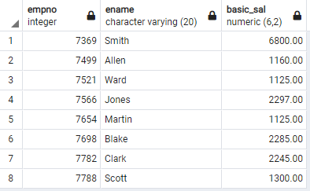



alter table employee add column join_date date;

select * from employee;

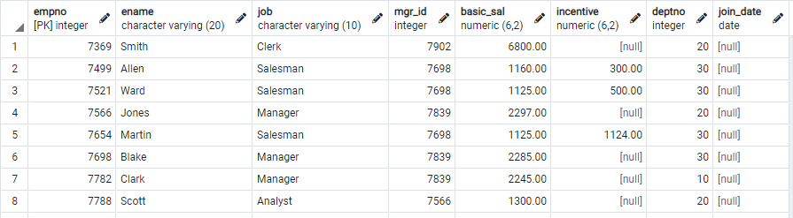



alter table department drop constraint department_pkey cascade;  
select * from department;

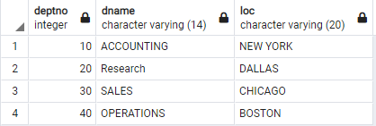



select ename from employee where ename like 'm%e%e%';

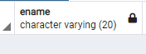



select ename from employee where ename like 'M%' and basic_sal > 1000;

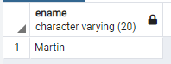



select count(*) from employee where basic_sal>2000;

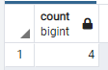



select * from employee order by deptno;

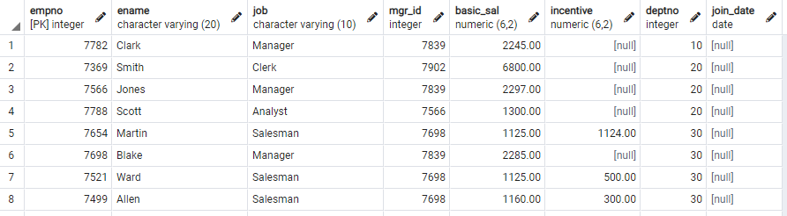



select deptno, count(*) from employee group by deptno;

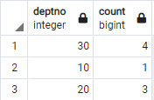



select deptno from employee group by deptno having count(*) > 10;

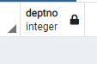

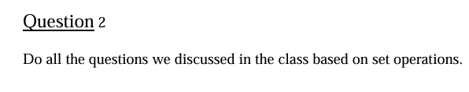

create table customer(cno int primary key,

cname varchar(30),

ctype varchar(10));

create table cust_fd(cno int references customer(cno),

fd_no int primary key,

fd_amt numeric(50),

int_rate numeric(50));

create table cust_loan(cno int references customer(cno),

ln_no int primary key,

ln_type varchar,

ln_amt numeric);

create table emp_details(cno int references customer(cno),

ename varchar,

sal numeric,

br_no int);

create table account(acc_no int primary key,

cno int references customer(cno),

veri_emp_no int,

acc_type varchar);

INSERT INTO customer (cno, cname, ctype) VALUES

(1, 'John Doe', 'Premium'),

(2, 'Jane Smith', 'Basic'),

(3, 'Alice Johnson', 'Premium'),

(4, 'Bob Brown', 'Basic'),

(5, 'Charlie Adams', 'Premium'),

(6, 'Diana Clark', 'Basic'),

(7, 'Evan Taylor', 'Premium'),

(8, 'Fiona Lewis', 'Basic'),

(9, 'George Martin', 'Premium'),

(10, 'Hannah Scott', 'Basic');

INSERT INTO cust_fd (cno, fd_no, fd_amt, int_rate) VALUES

(1, 1001, 50000, 4.5),

(2, 1002, 75000, 5.0),

(3, 1003, 60000, 4.8),

(4, 1004, 80000, 5.2),

(5, 1005, 55000, 4.7),

(6, 1006, 45000, 5.1),

(7, 1007, 95000, 4.9),

(8, 1008, 105000, 5.3),

(9, 1009, 62000, 4.6),

(10, 1010, 78000, 5.4);

INSERT INTO cust_loan (cno, ln_no, ln_type, ln_amt) VALUES

(1, 2001, 'Home Loan', 250000),

(2, 2002, 'Personal Loan', 50000),

(3, 2003, 'Car Loan', 120000),

(4, 2004, 'Education Loan', 30000),

(5, 2005, 'Home Loan', 270000),

(6, 2006, 'Car Loan', 150000),

(7, 2007, 'Personal Loan', 80000),

(8, 2008, 'Business Loan', 500000),

(9, 2009, 'Education Loan', 45000),

(10, 2010, 'Personal Loan', 100000);

INSERT INTO emp_details (cno, ename, sal, br_no) VALUES

(1, 'Mark Spencer', 55000, 101),

(2, 'Lucy Martin', 60000, 102),

(3, 'John David', 52000, 103),

(4, 'Emily White', 58000, 104),

(5, 'Michael James', 61000, 105),

(6, 'Sophia King', 54000, 106),

(7, 'Oliver Green', 57000, 107),

(8, 'Amelia Turner', 62000, 108),

(9, 'Mason Lee', 51000, 109),

(10, 'Isabella Wright', 53000, 110);

INSERT INTO account (acc_no, cno, veri_emp_no, acc_type) VALUES

(3001, 1, 1, 'Savings'),

(3002, 2, 2, 'Current'),

(3003, 3, 3, 'Savings'),

(3004, 4, 4, 'Current'),

(3005, 5, 5, 'Savings'),

(3006, 6, 6, 'Current'),

(3007, 7, 7, 'Savings'),

(3008, 8, 8, 'Current'),

(3009, 9, 9, 'Savings'),

(3010, 10, 10, 'Current');

**a)List the customer number of those customers who have got both loan and fd at the bank**

select cno from cust_fd intersect select cno from cust_loan

**b)List the customer number of those customers who have got either loan or fd at the bank**

select cno from cust_fd union select cno from cust_loan

**c)List the customer number of those customers who have got FD but not loan at the bank Insert customer details for those who have FD but no loan**

INSERT INTO customer (cno, cname, ctype) VALUES

(11, 'Ivy Cole', 'Premium'),

(12, 'Jackie Ford', 'Basic'),

(13, 'Kyle Evans', 'Premium');

**d) Insert customers with FD but no loan Assume customer numbers 11, 12, and 13 have FD but no loan**

INSERT INTO cust_fd (cno, fd_no, fd_amt, int_rate) VALUES

(11, 1011, 85000, 4.6),

(12, 1012, 70000, 4.8),

(13, 1013, 92000, 5.1);

select cno from cust_fd except select cno from cust_loan;